**Literature review (Expert System)**

Expert system are computer applications which embody some non-algorithmic expertise to solve certain type of problems. [1]

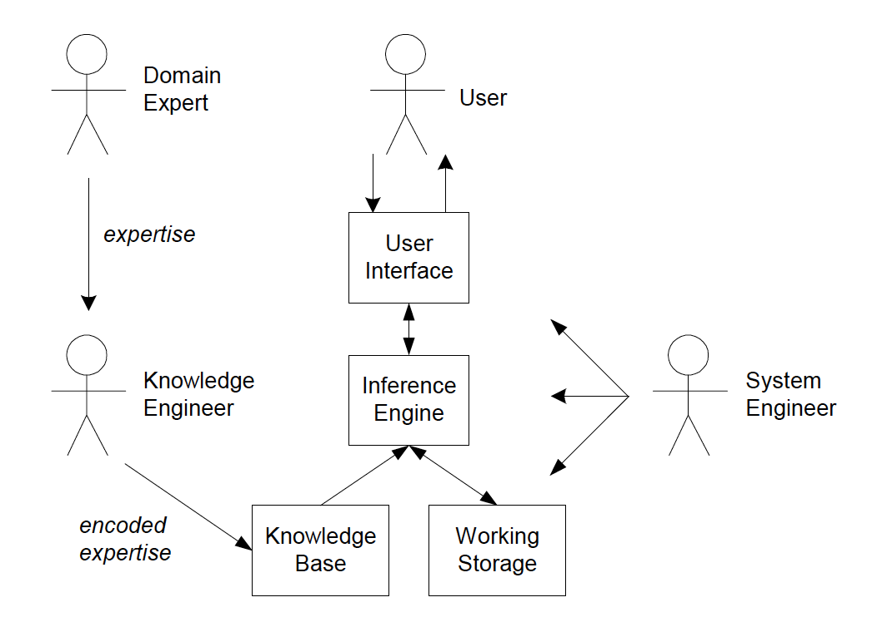

Expert systems have a number of major system components and interface with individuals in various roles.

• Knowledge base – a declarative representation of the expertise, often in IF THEN rules;

• Working storage – the data that is specific to a problem being solved;

• Inference engine – the code at the core of the system, which derives recommendations from the knowledge base and problem-specific data in working storage;

• User interface – the code that controls the dialog between the user and the system.

To understand expert system design, it is also necessary to understand the major roles of individuals who interact with the system. These are:

• Domain expert – the individual or individuals who currently are experts solving the problems the system is intended to solve;

• Knowledge engineer – the individual who encodes the expert's knowledge in a declarative form that can be used by the expert system;

• User – the individual who will be consulting

Expert system consist of several components such as knowledge base, working storage and inference engine. Knowledge base is a declarative representation of the expertise. The knowledge base is often written in IF THEN rules. Working storage is where the data is stored when the data specific to a problem being solved. The inference engine refers to the code at the core of the system. The inference engine will derives recommendations based on the knowledge base and the data stored in the working storage.

**Applications of Expert System:**

DENDRAL [2] - One of the earliest expert systems, DENDRAL analyses mass spectral patterns to suggest the chemical structure of unknown compounds (14).

MYCIN [2] - MYCIN is an expert system developed at Stanford University in the mid-1970s to aid physicians in the selection of antibiotics for patients with severe infections (9).

PROSPECTOR [2] - PROSPECTOR. PROSPECTOR is a mineral exploration consultation system

designed for problems in regional resource evaluation, ore deposit identification, and drilling site selection (17).

**Drawback:**

One of the major bottlenecks in building expert systems is the knowledge engineering process. The coding of the expertise into the declarative rule format can be a difficult and tedious task. One major advantage of a customized shell is that the format of the knowledge base can be designed to facilitate the knowledge engineering process.

Reference:

[1] Merritt, D.: Building experts systems in Prolog. Springer-Verlag, New York (1989)

[2] Duda, R. O., & Shortliffe, E. H. (1983). Expert systems research. *Science*, *220*(4594), 261-268.

## Literature Review (Uncertainty)

Uncertainty is where probabilistic descriptions appropriately capture the decision maker’s environment. [1]

Uncertainty is defined as the lack of the exact knowledge that would enable us to reach a perfectly reliable conclusion [Slides].

**Why uncertainty should be introduced into Expert System?**

It can come from our [1]:

* Laziness: It is too much work to list the complete set of antecedents or consequents needed to ensure an exceptionless rule and too hard to use such rules.
* Theoretical ignorance: Medical science has no complete theory for the domain.
* Practical ignorance: Even if we know all the rules, we might be uncertain about a particular patient because not all the necessary tests have been or can be run.
* User might enter data that is uncertain.
* There are rules where conclusion is uncertain.
* There are rules where the premise is uncertain.
* Combining uncertain premise with uncertain conclusion.

[2] Often in structured selection problems the final answer is not known with complete certainty. The expert's rules might be vague, and the user might be unsure of answers to questions. This can be easily seen in medical diagnostic systems where the expert is not able to be definite about the relationship between symptoms and diseases. In fact, the doctor might offer multiple possible diagnoses.

For expert systems to work in the real world they must also be able to deal with uncertainty. One of the simplest schemes is to associate a numeric value with each piece of information in the system. The numeric value represents the certainty with which the information is known. There are numerous ways in which these numbers can be defined, and how they are combined during the inference process.

**Applications of expert systems with uncertainty:**

MYCIN

[1] Russell, S., Norvig, P., & Intelligence, A. (2009). Artificial Intelligence: A Modern Approach (3rd Edition). Prentice-Hall, Egnlewood Cliffs, 25, 27.

[2] Merritt, D.: Building experts systems in Prolog. Springer-Verlag, New York (1989)